

Congratulations!

You are ready to buy a home!

*Check out a few (well, a lot) of our “rules” during*

*your home search process.*

1. Don’t quit your job.
2. Don’t change your job.
3. Don’t get a promotion.
4. Don’t buy any large ticket items.
5. Don’t make any untraceable deposits to your bank accounts.
6. Don’t talk to the sellers directly – “Loose lips sink ships”.
7. Do get a gift letter and a bank statement for funds.
8. Do tell the person who is giving you the gift that you will probably need a gift letter and some proof (usually a bank statement) that they had the money to give.
9. Do tell me if you are allergic to animals.
10. Do be completely honest with your lender about child support, alimony, wage garnishments or any other payroll deductions.
11. Don’t make any major purchases.
12. Don’t get buying advice from anyone who hasn’t bought in the last year. Things change weekly.
13. Don’t wait if you like a house.
14. Don’t trash the property in front of the owners.
15. Don’t call the numbers on the “For Sale” sign – call me, that’s my job!
16. Don’t attend open houses or new construction listings without me.
17. Don’t keep it a secret if you have a house to sell.
18. Don’t delay your paperwork because you are irritated at the number of requests and frequency from the mortgage company.
19. Don’t find a lender on the internet.
20. Don’t think you won’t find what you are looking for your first day out. I bought the first wedding dress I ever tried on….you might buy the first house you ever see. Its absolutely possible and quite probable!
21. Don’t go home to sleep on it in a hot market (a.k.a. the Triangle market right now).
22. Don’t wait to find the absolute perfect house. You will always be limited by something – income, zoning, inventory at the time, legislation, property taxes, etc.
23. Do follow the 80/10/10 rule: If you find a house that has 80% of what you are looking for, 10% of things you can change, and 10% of things you can live with, it’s a KEEPER!
24. Do not co-sign for even a candy bar.
25. Don’t schedule a vacation before we close, especially a cruise.
26. Don’t order Direct TV, cable or telephone or any utility that will pull your credit report unless you want to write a letter of explanation about the credit report to the mortgage company.
27. Don’t change your name during the mortgage process.
28. Do be completely honest with your loan officer about EVERYTHING.
29. Don’t have unreasonable expectations.
30. Do get a home warranty.
31. Don’t give away your negotiating power by talking at the wrong time.
32. Do not post your real estate thoughts on social media.
33. Do get a home inspection.
34. Do make sure you are approved for a loan BEFORE you go out looking.
35. Don’t believe everything you see on TV. Would you believe that reality TV is staged??? Who knew? HGTV and the DIY channel are both networks that carry SCRIPTED shows.
36. Do shop the Good Faith Estimate (GFE) with lenders.
37. Do be completely honest with me about what is most important to you in a house.
38. Don’t cancel appointments at the last minute (emergencies aside).
39. Do use an attorney who specializes in real estate.
40. Do use your complete legal name as seen on your driver’s license.
41. Do tell your lender if you lose your job before closing.
42. Do not go window shopping and let people pull your credit.
43. Do remember, if it can’t be written on the contract because it’s being done under the table, its likely mortgage fraud.
44. Do not look at short sales if you want to move in soon.
45. Do not consider short sales if you need to be in control of the process.
46. Do read the Professional Services Disclosure and consider hiring someone to complete each of those items listed during the transaction.
47. Do ask me any questions you have and I will find the right answer.
48. Do NOT die before the transaction closes, this messes things up BIG TIME. Please, please, please do not die before closing!

*Adapted from Terry Watson’s “Three Sheets” www.terrywatson.com*

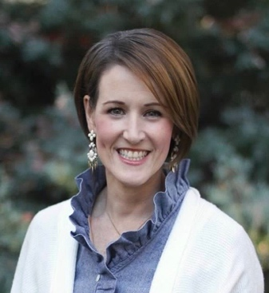

**Lori Edwards, REALTOR**

**RE/MAX United**

7721 Six Forks Road, Suite 100 Raleigh, NC 27615

LoriE@remax.net 919.272.1520